**: Game Programming:**

**: Assignment 4:**

**Game programming:**

Sir Omer Chattha

**Group members:**

Mubashar Azad **2369**

Muhammad Usman **2544**

Touqeer Ahmed **2328**

Zamama Zaman **2128**

**Score: 10/10**

**Task 1: Create a story board for all the levels of your game.**

**The Regeneration of Earth**

**Level 1: The spreading of Virus**

In this game the evil scientist has made a virus in his lab with which he wants to infect the people in this world. People are getting infected with virus each day. Doctors are surprised to see large number of cases in city in this hard time a secret agency has taken a note for this situation and assigned a mission to their most trusted agent miller to inspect the situation.

The first objective is to train Agent Miller. This is a highly secret mission. Agency boss and high authorities want a high-level training for their agent. Agent needs to pass these tests that include fitness and shooting tests. Once the training is finished, Miller is assigned with his first mission.

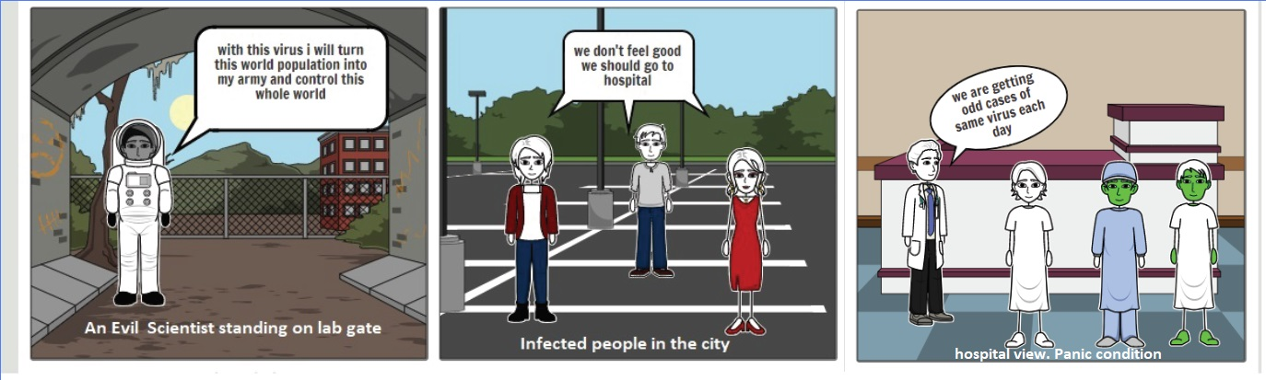

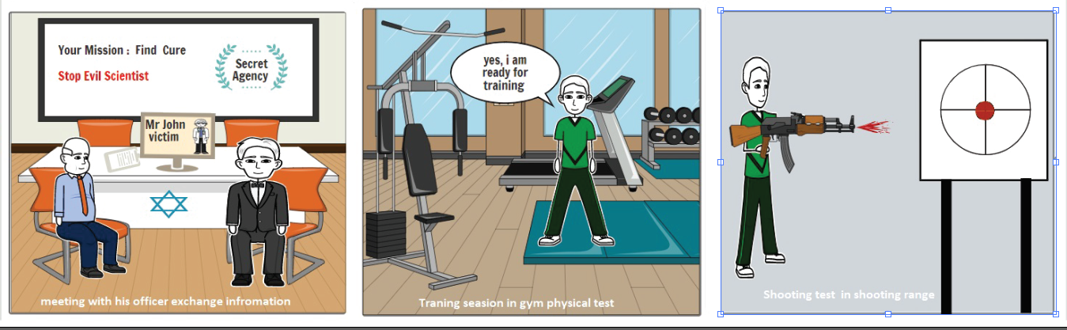

**Level 2: City inspection and get clues**

The agency has detected some suspicious activities in town. The agency send message to its most trusted agent Miller to check the activities in that area. The agent miller has to get into that hospital. He talks with doctor and doctor told him the cities in a bad condition. The agent finds some kind of virus that infects people in the town.

Agency give him another task. He went to a place where all people are infected quickly. In that place he needs to save himself from virus. After saving himself from infected people. He went into the center hospital of the town. That place helps us to find main reason of effecting people in the city.

He starts working according to his agency. Agency have already doubt on some doctors and hospital of this city. And he sends his officer to those hospitals and finally find some clues. He finds some clues in the hospital. He takes those clues to lab for testing to further investigate the situation.

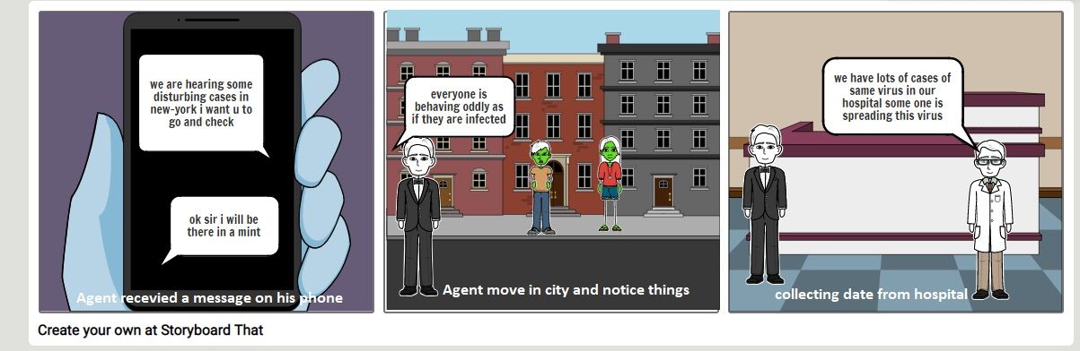

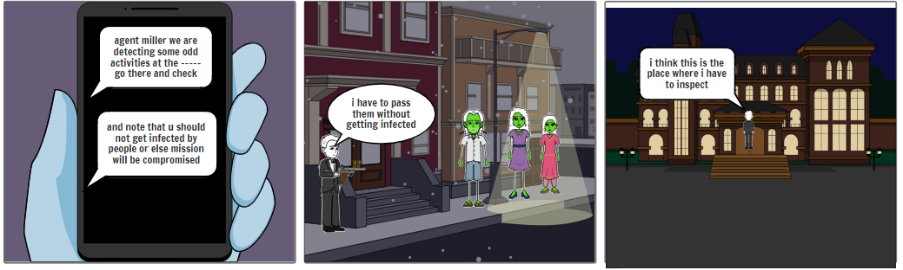

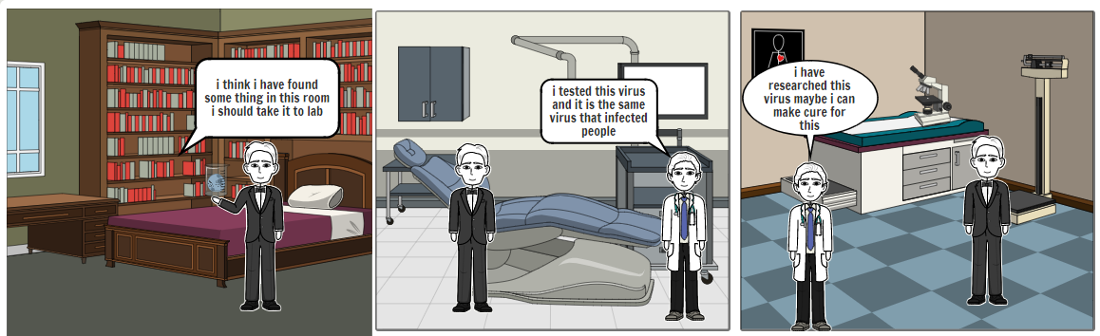

**Level 3: Arrest Evil Scientist**

Finally reach to his destination. Agent enter in the lab and find the evil scientist master mind of this evil activities. First of all, he turns off all the cameras and security officer sees him and starts fighting with him. He kills the officer and then enters in John (evil scientist) room and catches him.

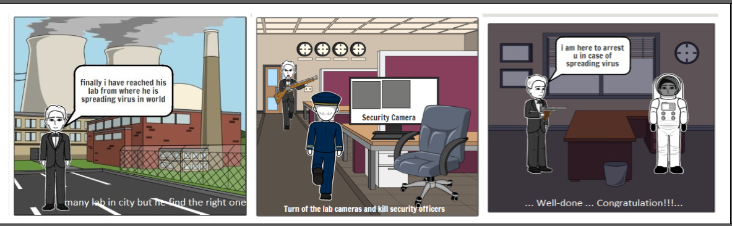

**Task:2 Create low fidelity prototypes for the interface of your game. This will include: Menu, Gameplay, Credits, Inventory and Exit Screen.**

**Menu:**

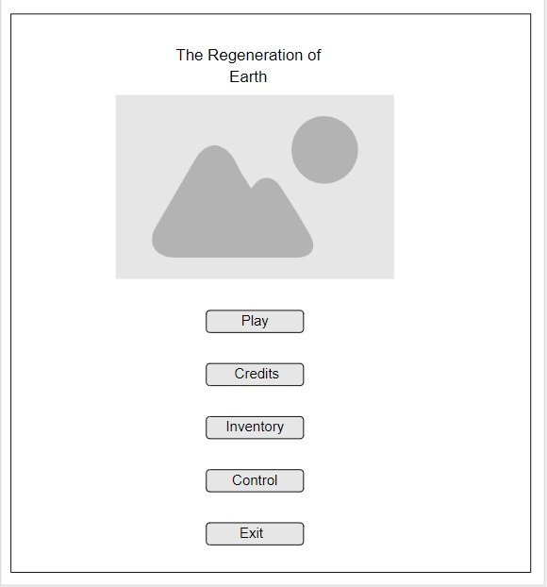

**Credits:**



**Inventory:**

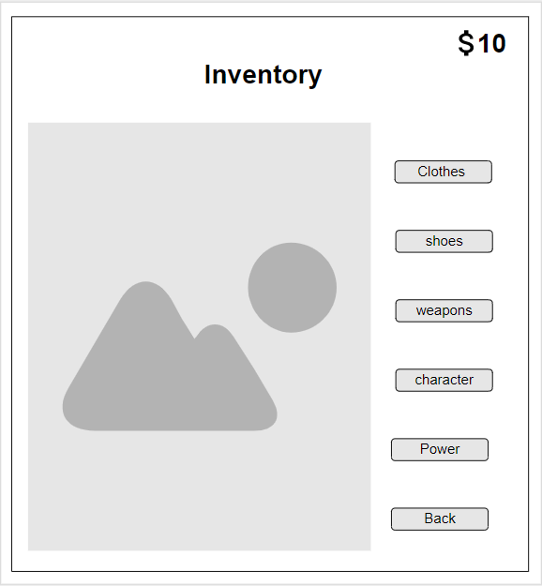

**Game Play:**

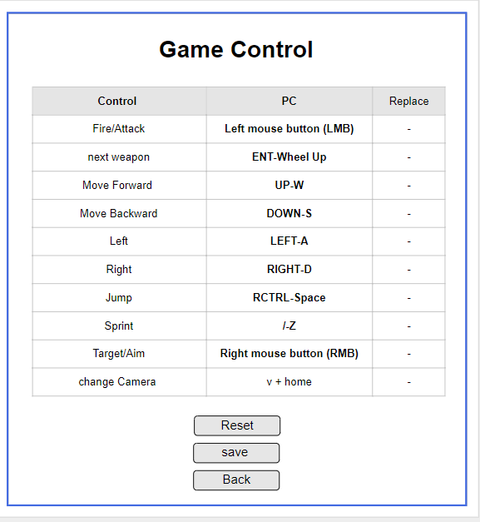

**Exist:**

